Airand — Data Model & Data Dictionary

Summary
Twelve tables hold everything Airand needs to run a zone, bill vendors, pay cyclists and judge viability. One table, delivery_event, is the backbone: every state change is an append-only row, so every KPI in the BRD can be computed from facts rather than from counters someone remembered to update.
Design principles
- Events are the source of truth. The timestamps on delivery (assigned_at, picked_up_at…) are a convenience copy written from events; if they ever disagree, the event wins.
- Money is a ledger, not a balance. A wallet's balance is the sum of its wallet_transaction rows; holds, settlements and refunds are rows, never edits.
- Personal data is minimised. Receiver phone numbers are encrypted at rest and masked in every export; verification codes are stored hashed.
- Everything is keyed for more zones. Every operational row carries zone_id, so a second zone is data, not a schema change (NFR-13).
- Configuration lives in rows. Rates, timers and limits sit on zone, so the system admin changes them without a release (FR-50).
What changed from the SRS's nine entities (DR-01 to DR-09). Three tables are added because the requirements need them once the detail is worked out: wallet_transaction (the ledger behind DR-03), shift (needed to compute cyclist utilisation and pay, FR-45, FR-49), and admin_user (the system admin and founder accounts behind role-based access, NFR-09). payment keeps one row per delivery summarising what was held, settled and refunded.
All example values in this document are simulated.

Entity-relationship diagram
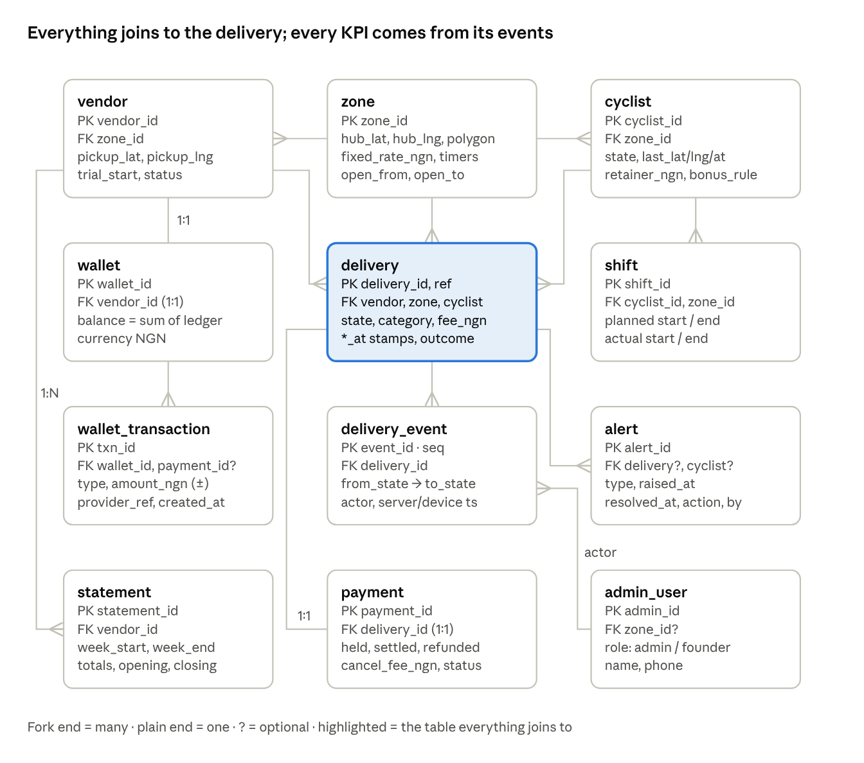
Airand ERD · 12 tables, 13 relationships
The delivery sits at the centre: it belongs to one zone and one vendor, is carried by at most one cyclist at a time, has exactly one payment summary, and accumulates an ordered stream of events and any alerts raised about it. Money flows through each vendor's wallet ledger; statements roll a vendor's week up from the same records.

Relationships and rules
Parent | Child | Cardinality | Rule | Why
zone | vendor | 1 : N | A vendor belongs to exactly one zone; its pickup pin must lie inside that zone's polygon | RUL-07
zone | cyclist | 1 : N | A cyclist is rostered to one zone at a time | BR-02
zone | delivery | 1 : N | Copied from the vendor at creation; never changes | Reporting by zone
vendor | wallet | 1 : 1 | Created at onboarding; never deleted | RUL-03
wallet | wallet_transaction | 1 : N | Append-only; balance = sum(amount_ngn) | Ledger principle
vendor | delivery | 1 : N | Every delivery has one vendor (the pickup) | BR-05
cyclist | delivery | 1 : N (optional) | delivery.cyclist_id = the current or final cyclist; null until Assigned; history of reassignments lives in events | FR-15, FR-17
cyclist | shift | 1 : N | No overlapping shifts per cyclist | FR-41, FR-45
delivery | delivery_event | 1 : N | seq is gapless per delivery, starting at 1; rows are never updated or deleted | FR-20, NFR-11
delivery | payment | 1 : 1 | Created with the request; settled or refunded exactly once | RUL-02, RUL-04, RUL-05
payment | wallet_transaction | 1 : N (optional) | A payment produces a hold row and, if cancelled, a refund row; top-ups have no payment | FR-06, FR-10
delivery | alert | 1 : N (optional) | Alerts can also hang off a cyclist alone (stale location) | FR-28
cyclist | alert | 1 : N (optional) | Either delivery_id or cyclist_id must be set | FR-18
vendor | statement | 1 : N | One per vendor per Monday–Sunday week; unique (vendor_id, week_start) | RUL-22
admin_user | delivery_event | 1 : N (as actor) | actor_type + actor_id point to a vendor, cyclist, admin_user or the system; not enforced as a single foreign key | FR-20

Data dictionary — reference and people
Conventions: uuid primary keys; timestamptz stored in UTC and displayed in West Africa Time; money as whole naira in integer (no kobo in the pilot); enums stored as text with a check constraint. PK = primary key, FK = foreign key, NN = not null.
zone — one row per delivery zone; holds its configuration (FR-50)
Column | Type | Keys / null | Description | Example
zone_id | uuid | PK | Zone identifier | —
name | text | NN, unique | Display name | Zone 1 · World Bank Road
polygon | geometry(Polygon) | NN | Boundary used for the in-zone test | 2.5 km radius around hub
hub_lat, hub_lng | numeric(9,6) | NN | Hub location | 5.4836, 7.0333
open_from, open_to | time | NN | Operating hours (RUL-08) | 12:00, 23:30
fixed_rate_ngn | integer | NN, > 0 | Fee per delivery (RUL-01) | 900
cancel_fee_pct | numeric(4,2) | NN | Fee kept if cancelled after assignment (RUL-04) | 0.20
ack_timeout_s, queue_alert_s, handover_grace_s, pickup_alert_s, delivery_alert_s, payment_expiry_s | integer | NN | Timers (RUL-02, 13, 14, 17, 23) | 60, 180, 300, 600, 1800, 600
max_weight_kg, max_value_ngn | numeric, integer | NN | Package limits (RUL-24) | 8, 50000
created_at, updated_at | timestamptz | NN | Audit | —
vendor — a business that requests deliveries
Column | Type | Keys / null | Description | Example
vendor_id | uuid | PK | — | —
zone_id | uuid | FK → zone, NN | Home zone | —
name | text | NN | Trading name | Mama Chi's Kitchen
contact_name | text | NN | Person responsible | Chioma
phone | text | NN, unique | E.164 format | +2348035551234
pickup_address | text | NN | As written | Plot 22, World Bank Road
pickup_lat, pickup_lng | numeric(9,6) | NN | Pinned at onboarding | —
category | text | NN | food · retail · print · other | food
trial_start | date | NN | Start of 7-day free trial (RUL-06) | 2026-10-01
status | text | NN | active · paused · offboarded | active
onboarded_by | uuid | FK → admin_user | Who onboarded them (FR-37) | —
created_at | timestamptz | NN | — | —
wallet and wallet_transaction — the vendor's prepaid balance as a ledger
Column | Type | Keys / null | Description | Example
wallet.wallet_id | uuid | PK | — | —
wallet.vendor_id | uuid | FK → vendor, NN, unique | One wallet per vendor | —
wallet.account_number | text | NN, unique | Virtual account from the payment provider (PayHold, demo) | 9012448317
wallet_transaction.txn_id | uuid | PK | — | —
wallet_transaction.wallet_id | uuid | FK → wallet, NN | — | —
wallet_transaction.payment_id | uuid | FK → payment, null | Set for hold and refund rows | —
wallet_transaction.type | text | NN | topup · hold · refund · adjustment | hold
wallet_transaction.amount_ngn | integer | NN, ≠ 0 | Signed: + top-up/refund, − hold | −900
wallet_transaction.provider_ref | text | null | Provider reference for top-ups | PH-77A31
wallet_transaction.created_at | timestamptz | NN | — | —
cyclist — an Airand rider
Column | Type | Keys / null | Description | Example
cyclist_id | uuid | PK | — | —
zone_id | uuid | FK → zone, NN | Current zone | —
name, phone | text | NN | — | Kelechi D.
state | text | NN | off_shift · available · assigned · to_vendor · at_vendor · delivering (RUL-12) | available
last_lat, last_lng, last_seen_at | numeric, timestamptz | null | Last reported location; stale after 5 min (FR-18) | —
retainer_ngn | integer | NN | Daily shift retainer (RUL-10) | 2310
bonus_threshold, bonus_per_delivery_ngn | integer | NN | Deliveries before bonus; bonus per extra delivery | 6, 150
trained_at | date | null | Training record (BR-20) | 2026-09-28
status | text | NN | active · suspended · left | active
shift — a rostered and actual working period
Column | Type | Keys / null | Description | Example
shift_id | uuid | PK | — | —
cyclist_id, zone_id | uuid | FK, NN | — | —
planned_start, planned_end | timestamptz | NN | From the weekly roster (RUL-09) | 15:30–23:30
actual_start, actual_end | timestamptz | null | From Start/End shift in the app (FR-41) | 15:34–23:31
admin_user — the system admin and the founder
Column | Type | Keys / null | Description | Example
admin_id | uuid | PK | — | —
zone_id | uuid | FK → zone, null | Null = all zones | —
name | text | NN | — | Chinedu
role | text | NN | system_admin · founder (NFR-09) | system_admin
phone, email | text | NN | — | —

Data dictionary — deliveries, money and records
delivery — one row per request; the hub of the model
Column | Type | Keys / null | Description | Example
delivery_id | uuid | PK | — | —
ref | text | NN, unique | Human reference shown on screens | AR-1042
zone_id, vendor_id | uuid | FK, NN | — | —
cyclist_id | uuid | FK → cyclist, null | Current or final cyclist | —
raised_by | text | NN | vendor · admin (phone-in, FR-12) | vendor
package_category | text | NN | food · documents · parcel · other (FR-52) | food
limits_confirmed | boolean | NN, must be true | Vendor ticked the limits box | true
dropoff_address | text | NN | As entered or pasted | 14 Okigwe Close, Housing Area H
dropoff_lat, dropoff_lng | numeric(9,6) | NN | Geocoded pin, inside zone | —
receiver_phone_enc | bytea | NN | Encrypted; masked in exports (NFR-08) | +234 803 ··· 4417
note | text(140) | null | For the cyclist | Blue gate
fee_ngn | integer | NN | Rate at time of request; 0 in trial | 900
state | text | NN | Current lifecycle state (11 values, FR-19) | picked_up
code_hash | text | null | Hash of the 4-digit code; set on assignment | —
tracking_token | text | NN, unique | ≥ 128-bit, for the receiver link (NFR-10) | —
created_at, paid_at, activated_at, assigned_at, arrived_at, picked_up_at, delivered_at, closed_at | timestamptz | null | Convenience copies of event times | —
vendor_delay | boolean | NN, default false | Handover > grace after arrival (FR-23) | false
without_code | boolean | NN, default false | Closed by phone check (FR-25) | false
outcome | text | null | delivered · failed · cancelled · expired | delivered
outcome_reason | text | null | From fixed list | receiver_unreachable
delivery_event — append-only history; the source for every KPI
Column | Type | Keys / null | Description | Example
event_id | uuid | PK | — | —
delivery_id | uuid | FK → delivery, NN | — | —
seq | integer | NN; unique (delivery_id, seq) | Order within the delivery | 6
event_type | text | NN | See event taxonomy | PICKED_UP
from_state, to_state | text | null | Null when the event does not change state | assigned → picked_up
actor_type | text | NN | vendor · cyclist · admin · system | cyclist
actor_id | uuid | null | Null for system | —
server_ts | timestamptz | NN | Authoritative time | 2026-10-09 20:18:04 UTC
device_ts | timestamptz | null | Time on the phone, for offline actions (FR-44) | —
lat, lng | numeric(9,6) | null | Where it happened, if known | —
reason, note | text | null | Mandatory for overrides and failures | —
payment — one money summary per delivery
Column | Type | Keys / null | Description | Example
payment_id | uuid | PK | — | —
delivery_id | uuid | FK, NN, unique | — | —
method | text | NN | wallet · transfer | wallet
amount_held_ngn | integer | NN | Fee held at request | 900
amount_settled_ngn | integer | NN, default 0 | Recognised as Airand revenue | 900
amount_refunded_ngn | integer | NN, default 0 | Returned to wallet | 0
cancel_fee_ngn | integer | NN, default 0 | Kept on post-assignment cancellation | 0
status | text | NN | pending · held · settled · refunded · part_refunded · expired | settled
held_at, settled_at | timestamptz | null | — | —
 |  | check | held = settled + refunded once final | —
alert — something the system admin must look at
Column | Type | Keys / null | Description | Example
alert_id | uuid | PK | — | —
zone_id | uuid | FK, NN | — | —
delivery_id, cyclist_id | uuid | FK, null; at least one set | Subject | AR-1042
type | text | NN | ack_timeout · queued · not_picked_up · late_delivery · vendor_delay · code_locked · stale_location · sync_delay | not_picked_up
raised_at | timestamptz | NN | — | —
resolved_at | timestamptz | null | — | —
resolved_by | uuid | FK → admin_user, null | — | Chinedu
action | text | null | What was done | reassigned
statement — a vendor's week
Column | Type | Keys / null | Description | Example
statement_id | uuid | PK | — | —
vendor_id | uuid | FK, NN | — | —
week_start, week_end | date | NN; unique (vendor_id, week_start) | Monday–Sunday | 2026-09-28, 2026-10-04
delivered, failed, cancelled | integer | NN | Counts | 46, 1, 2
fees_ngn, cancel_fees_ngn, topups_ngn | integer | NN | Totals | 42300, 180, 45000
opening_ngn, closing_ngn | integer | NN | Wallet balance at start and end | 4780, 7300
vendor_delays | integer | NN | Count for the coaching note | 3
generated_at | timestamptz | NN | Monday 06:00 | —

Event taxonomy
Twenty-two event types cover the whole lifecycle in the Future-State Design. Events that change state carry from_state and to_state; the rest record something that happened without moving the delivery. The Feeds column names the measures each event supports; the KPI definitions in the next step are written against these event types.
Event type | From → to | Actor | Written when | Feeds
REQUEST_CREATED | — → pending_payment | vendor / admin | Request submitted | Demand by hour
PAYMENT_HELD | pending_payment → active | system | Fee held from wallet or transfer confirmed | Payment latency
PAYMENT_EXPIRED | pending_payment → expired | system | 10 min without payment | Expiry rate
QUEUED | active → awaiting_cyclist | system | No cyclist available | Queue rate, queue time
CYCLIST_PROMPTED | — | system | A cyclist is offered the job (one per attempt) | Offers per assignment
CYCLIST_ACCEPTED | active / awaiting / reassigning → assigned | cyclist | Accept tapped | Request-to-assignment
ACK_TIMEOUT | — (offer withdrawn, next cyclist prompted) | system | 60 s without accept | Unresponsive rate per cyclist
REASSIGNED | assigned → reassigning | admin | Admin override with reason | Override rate
ARRIVED_AT_VENDOR | — | cyclist / system (geofence) | Tap or 50 m for 30 s | Cyclist pickup wait
VENDOR_DELAY_FLAGGED | — | system | No pickup 5 min after arrival | Vendor delay rate
PICKED_UP | assigned → picked_up | cyclist | Handover confirmed | Vendor handover time
REFUSED_AT_PICKUP | assigned → cancelled | cyclist | Package outside limits (FR-53) | Refusal rate
ARRIVED_AT_DROPOFF | — | cyclist | Slide at the door | Last-metre wait
CODE_FAILED | — | cyclist | Wrong code entered | Code friction
CODE_LOCKED | — | system | Third wrong code | Alerts
DELIVERED | picked_up → delivered | cyclist | Correct code | Delivery time, on-time %
DELIVERED_WITHOUT_CODE | picked_up → delivered | cyclist | Phone-confirmed handover | Review volume
FAILED | picked_up → failed | cyclist / admin | Receiver unreachable or refused (RUL-19) | Failure rate and reasons
CANCELLED | active / awaiting / assigned → cancelled | vendor / admin | Cancel with reason | Cancellation rate, fees kept
CLOSED | delivered / failed → closed | admin / system | Review done or 24 h after delivery | Close lag
MESSAGE_SENT | — | system | Code and link sent; channel recorded | Message cost, SMS fallback rate
SYNC_LATE | — | system | Offline action arrived > 2 min late | Connectivity issues
Rules. seq increments by one per delivery. A state-changing event is rejected if from_state does not equal the delivery's current state, which is how the database enforces the lifecycle. Offline actions keep device_ts but are ordered by server_ts.

Data quality, privacy and retention
Area | Rule | Enforced by | Requirement
Lifecycle integrity | A state change must start from the delivery's current state; seq is gapless | Database check on insert into delivery_event | FR-19, FR-20
Immutability | delivery_event and wallet_transaction rows are never updated or deleted; corrections are new rows | No update/delete grants on those tables | NFR-11
Money balances | payment: held = settled + refunded once final; wallet balance never below 0 | Check constraint; hold refused if insufficient | RUL-02, RUL-04
Location sanity | Pins must fall inside Nigeria's bounding box; drop-offs inside the zone polygon | Geocoding step and zone test | FR-03
Time | Server time is authoritative; device time is kept but never used for ordering | Event writer | FR-44
Receiver phone | Encrypted at rest; visible only to the assigned cyclist during the job, the system admin and the requesting vendor; masked in reports and exports | Column encryption + role-based views | NFR-08
Codes and links | Codes stored hashed; tracking token stops resolving 24 h after the delivery ends | Application | NFR-10, FR-40
Retention | All operational records kept ≥ 12 months, exportable as CSV for CLRD inspection and disputes; receiver phone purged after 12 months | Scheduled job | BR-22, NFR-12
Synthetic data | Every dataset made for the portfolio is labelled SIMULATED in its file name and first row; no real phone numbers are used | Generator script | Portfolio rule

Traceability and next steps
SRS data requirement | Table(s) here
DR-01 Zone | zone
DR-02 Vendor | vendor
DR-03 Wallet | wallet, wallet_transaction
DR-04 Cyclist | cyclist, shift
DR-05 Delivery | delivery
DR-06 Event | delivery_event
DR-07 Payment | payment
DR-08 Statement | statement
DR-09 Alert | alert
NFR-09 role-based access | admin_user
Next in Phase 8 (data track)
- ☐ KPI definitions: each BRD success criterion and management measure written once, as a formula over these tables and events
- ☐ Synthetic dataset: 90 days, 8 vendors (2 anchors), 10 cyclists, demand ramping from ~30 to ~70 deliveries a day with a 7–11 PM peak, labelled as simulated
- ☐ SQL for every KPI against the dataset
- ☐ Dashboard answering the founder's question: is Zone 1 viable, and what should change?

